CRIME ANALYSIS

#### Report

SUBMITTED IN PARTIAL FULFILMENT OF THE REQUIREMENTS FOR MINOR PROJECT

#### Duration

**(from )**

**SUBMITTED BY**

#### Name :- XXXXXXXX Branch :- XXXXX

#### Roll No :- XXXXX

**Univ. Roll No :-XXXX**



#### Department of Computer Science & Engineering DAV Institute of Engineering & Technology

Jalandhar, India

## **Abstract**

Crime rates in India have long been a focal point for researchers, policymakers, and law enforcement agencies due to their significant impact on the socio-economic and political landscape of the country. This report endeavors to provide a comprehensive and detailed analysis of crime trends across various categories, including violent crimes, property crimes, cybercrimes, and socio-economic crimes, over the past decade. Utilizing data primarily from the National Crime Records Bureau (NCRB), supplemented with information from additional reputable sources, this study applies rigorous statistical methodologies to uncover patterns and trends that are critical for informed decision-making.

The analysis delves into the geographical distribution of crimes, identifying high-crime regions and potential hotspots. By mapping these distributions, the study aims to pinpoint areas that require urgent intervention and resource allocation. Additionally, the report examines the temporal trends in crime rates, offering insights into how crime has evolved over time and the factors that might influence these changes.

One of the significant aspects of this study is its focus on the correlation between different types of crimes and various socio-economic factors such as poverty, unemployment, education levels, and urbanization. This multidimensional approach provides a nuanced understanding of the causes and facilitators of crime, enabling the formulation of more targeted and effective crime prevention strategies.

Data visualization plays a crucial role in this report, with comprehensive charts, graphs, and maps illustrating the key metrics and findings. These visual aids are designed to make complex data accessible and comprehensible, facilitating better understanding and communication of the results.

In addition to presenting the findings, this report critically evaluates the implications of these trends for policy and practice. By comparing current findings with past research, the study highlights consistencies and discrepancies, offering a reflective perspective on the effectiveness of existing policies and identifying areas for future improvement. The insights derived from this study are intended to inform policymakers, law enforcement agencies, and the wider research community, providing a robust evidence base for developing strategies aimed at reducing crime and enhancing public safety.

Ultimately, this report aspires to contribute meaningfully to the discourse on crime prevention and public safety in India. By offering detailed analysis and practical recommendations, it aims to support ongoing efforts to create safer communities and a more secure society

**Acknowledgement**

The successful completion of this project report, titled "Crime Rates in India," represents a collective effort supported by numerous individuals and institutions. I would like to express my deepest gratitude to GNA University for providing an academic environment rich with resources, support, and encouragement. The access to comprehensive academic databases, analytical tools, and the supportive infrastructure was fundamental to the execution of this research.

I am profoundly thankful to my mentor, [Mentor's Name], whose unwavering support, expert guidance, and insightful feedback were pivotal throughout this research journey. Their dedication to academic excellence and commitment to mentoring has significantly shaped this project. Their suggestions and constructive criticism have greatly enhanced the quality and depth of this analysis.

I would also like to extend my gratitude to my professors and peers at GNA University. The academic discussions, collaborative efforts, and peer feedback have provided diverse perspectives and have been instrumental in broadening my understanding of the complex issues related to crime rates in India.

A special acknowledgment goes to the National Crime Records Bureau (NCRB) for their meticulous collection and dissemination of crime data, which formed the backbone of this study. The accuracy and comprehensiveness of the NCRB data have been crucial to ensuring the validity and reliability of this research. I also wish to thank other organizations and researchers whose work and data have been referenced and utilized in this report.

I am incredibly grateful to my family and friends for their constant support, patience, and encouragement. Their belief in my abilities and their understanding during the demanding periods of research and writing have been a source of immense motivation and strength.

Moreover, I would like to thank all those who have contributed directly or indirectly to this project. Your support, whether it was through intellectual contributions, moral support, or practical assistance, has been invaluable. Each contribution has played a role in bringing this project to fruition.

Finally, I would like to acknowledge the broader academic and research community, whose collective body of work has inspired and informed this study. It is my hope that this report will, in turn, contribute to the ongoing efforts to understand and mitigate crime rates in India, helping to foster a safer and more secure society.

**Table of Contents**

**Contents** **Page No.**

**Abstract** ......................................................................................i  
**Acknowledgment** ......................................................................ii **List of Figures** ............................................................. iii **Table of Contents**  ...................................................................... iv

1. **Introduction** ....................................................................
   * Objective of the analysis
   * Brief description of crime rates in India
2. **Dataset Overview** .............................................................
   * Source of the dataset (Kaggle)
   * Description of the dataset columns and data types
   * Loading the dataset into a Pandas DataFrame
3. **Data Preprocessing** ........................................................
   * Handling missing values
   * Data cleaning and normalization
   * Feature engineering (if applicable)
4. **Exploratory Data Analysis (EDA)** .......................................
   * Descriptive statistics
   * Identifying trends and patterns
   * Correlation analysis
5. **Data Visualization** ..........................................................
   * Plotting the crime trends over time
   * Geographical distribution of crimes
   * Visualization of key metrics (e.g., types of crimes, crime rates)
6. **Technologies Used** ............................................

* Python
* Streamit
* Pandas
* Numpy
* Matplotlib
* Seaborn

1. **Design and Implementation……………………………….**
2. **Conclusion & Future Scope** ....................................................................
   * Summary of findings
   * Insights and recommendations
   * Limitations of the analysis
3. **References** .....................................................................
   * Citing data sources and literature used in the analysis

## 

## **INTRODUCTION TO THE INDUSTRY /INSTITUTION CONTENTS**



#### NATURE OF BUSINESS OF THE INDUSTRY / INSTITUTION

O7 Services is an ISO 9001:2015 Certified Organization. Fundamentally, deal in Web Designing, Mobile Development, Custom Software Development, Web Designing, Graphic Designing, Hosting services, Digital Marketing, Registration of Domain Names with the various latest extensions, Internet and Social Media Marketing, Search Engine Optimization (SEO), Pay Per Click (PPC) Management, and give the most experienced IT solutions, supporting the full business cycle: preliminary counselling, framework development and deployment, quality confirmation, and 24x7 backings.

With a rich encounter of over 8 years, O7 Services is in general form dependable key organisation with their clients to guarantee affordable costs, opportune conveyance, and quantifiable business results. The Head Office of O7 Services is in Jalandhar and the Branch Office is in Hoshiarpur

With more than 30 team members as of the year 2023, they have provided services to many major and minor organisations, start-ups, and public and private establishments. The vision of O7 Services is to help their clients with figuring out their fantasies and work with them with prime administrations that beat their assumptions, and hence, add to a prevalent society for their clients and various accomplices as well as broad society. They will continue with their drive to grasp this vision.

#### DIFFERENT PRODUCTS / ACTIVITIES OF THE INDUSTRY / INSTITUTION

Since its establishment, O7 Services has worked with a wide range of products from Learning Management System (LMS) to custom ERP software. It has provided its support to the various organisations like LMS, E-commerce websites, Betting Strategy websites, Tracking Systems, School Management System, Informative Websites, HR ERP Softwares. The company of O7 Services has worked very closely with innumerable customers by providing the best of the work. Some of the company products and websites that are designed by O7 Services are as follows-







   





## **CHAPTER 1**

## **INTRODUCTION**

## **Introduction**

## Crime rates in India have been a subject of significant interest and concern due to their profound impact on the social, economic, and political landscape of the nation. Understanding the dynamics of crime in the country is crucial for policymakers, law enforcement agencies, and the public at large. India, with its vast and diverse population, presents unique challenges in crime prevention and management. The legal and law enforcement framework of the country has evolved over time to address various types of crimes, ranging from violent offenses to cybercrimes.

## In recent years, India has witnessed a considerable shift in the nature and frequency of crimes. Rapid urbanization, economic disparities, technological advancements, and social changes have all contributed to this transformation. The National Crime Records Bureau (NCRB), an essential agency under the Ministry of Home Affairs, plays a pivotal role in collecting and analyzing crime data across the country. Their comprehensive datasets provide valuable insights into crime trends, helping to formulate effective strategies for crime prevention and control.

## Crime in India encompasses a wide range of activities, including violent crimes, property crimes, cybercrimes, and socio-economic crimes. Each category has distinct characteristics and underlying causes that need to be understood to devise targeted interventions. This report delves into the trends, patterns, and correlations of different types of crimes, offering a detailed analysis based on NCRB data and other credible sources.

## **Objective**

## The primary objective of this project is to conduct a thorough analysis of crime rates in India using data from the National Crime Records Bureau (NCRB) and other relevant sources. Specifically, this study aims to:

## **Analyze the incidence and distribution of different types of crimes across India:**

## This includes violent crimes (e.g., homicide, assault), property crimes (e.g., theft, burglary), and emerging crimes such as cybercrimes.

## **Identify trends and patterns in crime rates over time:**

## By examining historical data, this study seeks to uncover long-term trends and periodic fluctuations in crime rates.

## **Investigate the correlation between socio-economic factors and crime rates:**

## Factors such as poverty, unemployment, education levels, and urbanization are analyzed to understand their impact on crime.

## **Explore the geographical distribution of crimes:**

## Identifying crime hotspots and regions with high crime rates to inform resource allocation and policy interventions.

## **Visualize crime data using various data visualization techniques:**

## Creating graphs, charts, and maps to illustrate key findings and make complex data accessible and comprehensible.

## **Assess the effectiveness of current crime prevention strategies:**

## By comparing current trends with past data, the study evaluates the success of existing policies and identifies areas for improvement.

## **Provide insights and recommendations for policymakers and law enforcement agencies:**

## Offering data-driven suggestions to enhance crime prevention and control measures.

## This objective framework allows for a comprehensive analysis of crime rates in India, covering various aspects of crime and its impact on society. It provides a structured approach to exploring the data, identifying trends, and drawing meaningful conclusions from the analysis.

**Description of Crime in India**

Crime in India is a multifaceted issue influenced by a complex interplay of socio-economic, cultural, and legal factors. The NCRB, established in 1986, has been instrumental in collecting and analyzing crime data, providing a reliable basis for understanding crime trends in the country. The following are key aspects of crime and its impact in India:

1. **Types of Crimes**:
   * **Violent Crimes**:
     + Violent crimes such as murder, rape, assault, and kidnapping have a profound impact on the victims and their families, creating a pervasive sense of insecurity in society. Understanding the underlying causes and trends of these crimes is essential for effective law enforcement and prevention strategies.
   * **Property Crimes**:
     + Crimes such as theft, burglary, and robbery are widespread in both urban and rural areas. These crimes often result in significant economic losses and psychological distress for the victims. Analyzing patterns in property crimes can help in devising targeted measures to reduce their occurrence.
   * **Cybercrimes**:
     + With the rapid increase in internet penetration and digitalization, cybercrimes have emerged as a significant threat. These include online fraud, identity theft, and cyberbullying, among others. The dynamic nature of cybercrimes requires constant vigilance and adaptive strategies to combat them.
2. **Geographical Distribution**:
   * Crime rates vary significantly across different states and regions in India. Urban areas, with their dense populations and economic activities, tend to report higher crime rates compared to rural areas. However, certain rural areas also experience high crime rates due to factors such as poverty and lack of law enforcement resources. Understanding the geographical distribution of crimes helps in identifying hotspots and allocating resources effectively.
3. **Socio-economic Factors**:
   * Various socio-economic factors influence crime rates in India. Poverty, unemployment, lack of education, and social inequality are some of the key drivers of crime. Analyzing the correlation between these factors and crime rates can provide insights into the root causes of criminal behavior and inform policies aimed at addressing these issues.
4. **Law Enforcement and Legal Framework**:
   * India has a comprehensive legal framework to address different types of crimes. However, the effectiveness of law enforcement agencies varies across regions. Issues such as corruption, lack of resources, and inadequate training often hamper the efficiency of law enforcement. Strengthening the legal and institutional framework is crucial for improving crime prevention and control.
5. **Impact on Society**:
   * Crime has far-reaching impacts on society. It affects the quality of life, creates a sense of fear and insecurity, and hampers economic development. High crime rates also strain the criminal justice system and public resources. Addressing crime effectively requires a holistic approach that takes into account its social, economic, and psychological impacts.
6. **Trends and Patterns**:
   * Analyzing trends and patterns in crime data helps in understanding the evolving nature of crime. For example, while traditional crimes such as theft and burglary may show a declining trend, cybercrimes and financial frauds are on the rise. Identifying these trends can guide law enforcement and policy decisions.

**CHAPTER 2**

**DATASET OVERVIEW**

**About Dataset**

The dataset used for this analysis is sourced from Kaggle and includes comprehensive records of crimes reported across India. The dataset, provided by the National Crime Records Bureau (NCRB), covers a wide range of crime types and spans multiple years, offering a rich source of information for analysis. The dataset includes the following key columns:

1. **Year**: The year in which the crime was reported.
2. **State/UT**: The state or union territory where the crime was reported.
3. **District**: The district within the state or union territory where the crime occurred.
4. **Crime Type**: The category of the crime (e.g., murder, theft, cybercrime).
5. **Victims**: The number of victims involved in the crime.
6. **Cases Reported**: The number of cases reported for each crime type.

This dataset is loaded into a Pandas DataFrame for further processing and analysis. Below is the code snippet to load the dataset:

python

Copy code

import pandas as pd

# Load the dataset

Import pandas as pd

df = pd.read_csv(“filename”)

### **CHAPTER 3**

### **Data Preprocessing**

Effective data preprocessing is crucial for ensuring the accuracy and reliability of any analysis. In this section, we detail the steps taken to prepare the dataset for analysis, addressing issues such as missing values, data cleaning, normalization, and feature engineering.

#### **Handling Missing Values**

Missing values in the dataset can skew the analysis and lead to inaccurate conclusions. The following steps were taken to handle missing values:

* **Identification:** Used descriptive statistics and visualization techniques to identify missing values across different columns.
* **Imputation:** For numerical columns, missing values were imputed using the mean or median of the respective columns. For categorical columns, the mode was used to fill missing values.
* **Removal:** In cases where the proportion of missing values in a column was very high (e.g., more than 50%), the column was removed from the analysis. Similarly, rows with a large number of missing values were also removed if they were not critical to the analysis.

#### **Data Cleaning**

Data cleaning involves correcting or removing inaccurate records from the dataset. The following steps were taken to clean the data:

* **Duplicate Removal:** Identified and removed duplicate records to ensure each entry in the dataset was unique.
* **Standardization:** Standardized text data to ensure consistency. This included converting all text to lowercase, removing leading and trailing spaces, and standardizing date formats.
* **Outlier Detection and Handling:** Identified outliers using statistical methods such as z-scores and IQR (Interquartile Range). Depending on the context, outliers were either corrected (if possible) or removed from the dataset.

#### **Data Normalization**

Normalization was performed to scale numerical data to a standard range, which is particularly important for algorithms that are sensitive to the scale of data, such as clustering and regression.

* **Min-Max Scaling:** Applied Min-Max scaling to bring all numerical features into the range [0, 1].
* **Standardization:** Applied standardization to transform the data to have a mean of 0 and a standard deviation of 1, especially for features with different units and scales.

#### **Feature Engineering**

Feature engineering involves creating new features or modifying existing ones to enhance the predictive power of the model. The following new features were engineered:

* **Crime Rate per 100,000 People:** Calculated the crime rate for each region by normalizing the number of crimes by the population size.
* **Yearly Growth Rate of Crimes:** Computed the yearly growth rate of crimes to identify trends and patterns over time.
* **Severity Index:** Developed a severity index for different crimes based on their legal implications and social impact.
* **Region-wise Aggregation:** Aggregated data at the state and district levels to analyze ­­regional crime patterns.

#### **Data Transformation**

Data transformation was applied to convert the data into a suitable format for analysis and modeling.

* **Encoding Categorical Variables:** Converted categorical variables into numerical values using techniques such as one-hot encoding and label encoding.
* **Date-Time Processing:** Extracted relevant information from date-time fields, such as year, month, and day, to analyze temporal patterns.

#### **Data Integration**

Integrated multiple datasets to enrich the analysis. This included merging datasets based on common keys and aligning data from different sources to create a comprehensive dataset.

* **Merging Datasets:** Used inner, outer, and left joins to combine datasets based on common identifiers.
* **Aligning Data Sources:** Ensured consistency in data formats and units across different datasets before merging.

**CHAPTER 4**

**Exploratory Data Analysis (­EDA)**

Exploratory Data Analysis (EDA) is a critical step in understanding the dataset and extracting initial insights. EDA involves summarizing the main characteristics of the data and visualizing various aspects to uncover patterns, anomalies, and relationships. This section provides a detailed account of the EDA performed on the dataset.

#### **Descriptive Statistics**

Descriptive statistics provide a summary of the central tendency, dispersion, and shape of the dataset’s distribution.

* **Central Tendency:** Calculated mean, median, and mode for numerical features to understand the typical values in the dataset.
* **Dispersion:** Computed range, interquartile range (IQR), variance, and standard deviation to assess the spread of the data.
* **Distribution Shape:** Analyzed skewness and kurtosis to understand the asymmetry and peakedness of the data distribution.

#### **Univariate Analysis**

Univariate analysis involves examining each variable individually to understand its distribution and key characteristics.

* **Frequency Distribution:** Plotted frequency distributions for categorical variables to see the occurrence of different categories.
* **Histograms and Density Plots:** Created histograms and density plots for numerical variables to visualize their distribution.
* **Box Plots:** Used box plots to visualize the spread and identify potential outliers in numerical variables.

#### **Bivariate Analysis**

Bivariate analysis explores the relationship between two variables, which helps in identifying correlations and dependencies.

* **Scatter Plots:** Created scatter plots to visualize the relationship between pairs of numerical variables.
* **Correlation Matrix:** Computed the correlation matrix and visualized it using a heatmap to identify strong positive or negative correlations.
* **Cross-tabulation:** Used cross-tabulation to explore relationships between categorical variables.
* **Bar Plots and Stacked Bar Plots:** Used bar plots to compare categories across different variables and stacked bar plots to show the distribution of categories within another categorical variable.

#### **Multivariate Analysis**

Multivariate analysis examines the interactions between multiple variables simultaneously to uncover complex relationships.

* **Pair Plot:** Created pair plots to visualize relationships between several numerical variables at once.
* **Principal Component Analysis (PCA):** Applied PCA to reduce the dimensionality of the data and identify the principal components that explain the most variance.
* **Clustering Analysis:** Performed clustering (e.g., K-means) to group similar data points and identify patterns.

#### **Temporal Analysis**

Temporal analysis investigates how the data changes over time, which is crucial for understanding trends and seasonality.

* **Time Series Plots:** Created time series plots to visualize trends in crime rates over different years.
* **Seasonal Decomposition:** Decomposed the time series data to analyze seasonal patterns, trends, and residuals.
* **Moving Averages:** Calculated moving averages to smooth out short-term fluctuations and highlight long-term trends.

#### **Geographical Analysis**

Geographical analysis examines the spatial distribution of the data to identify regional patterns and hotspots.

* **Choropleth Maps:** Created choropleth maps to visualize crime rates across different states and districts.
* **Heat Maps:** Generated heat maps to show the density of crimes in various regions.
* **Geospatial Clustering:** Applied geospatial clustering techniques to identify clusters of high and low crime areas.

#### **Distribution Analysis by Crime Type**

Analyzed the distribution of different types of crimes to understand their prevalence and impact.

* **Crime Type Frequency:** Calculated the frequency of each crime type and visualized it using bar charts.
* **Severity and Impact:** Assessed the severity and impact of different crimes by considering factors such as average number of victims, legal implications, and social impact.

#### **Victim and Offender Analysis**

Examined the characteristics of victims and offenders to identify patterns and risk factors.

* **Demographic Analysis:** Analyzed demographic information (age, gender, etc.) of victims and offenders.
* **Repeat Offenders:** Identified patterns of recidivism by examining individuals with multiple offenses.
* **Victim-Offender Relationship:** Explored the relationship between victims and offenders to understand the context of crimes.

#### **Efficiency of Judicial Process**

Evaluated the efficiency of the judicial process in handling crime cases.

* **Case Disposal Rates:** Calculated the rates at which cases were disposed of by police and courts.
* **Time to Resolution:** Analyzed the time taken to resolve cases at different stages of the judicial process.
* **Conviction Rates:** Examined the conviction rates for different types of crimes to assess the effectiveness of the legal system.

#### **Insights from EDA**

Summarized key insights and findings from the EDA:

* **Trends and Patterns:** Highlighted major trends and patterns observed in the data.
* **Geographical Hotspots:** Identified regions with high crime rates and specific crime types.
* **Temporal Changes:** Discussed significant changes in crime rates over the years.
* **Demographic Risk Factors:** Identified demographics that are more vulnerable to certain types of crimes.
* **Judicial Efficiency:** Assessed the efficiency and effectiveness of the judicial process in handling crimes.

### **CHAPTER 5**

### **Data Visualization**

Data visualization is a powerful tool for conveying complex data insights in an accessible and comprehensible manner. In this section, we illustrate the various visualizations used to analyze the dataset, which provide clear and impactful representations of the data.

#### **Visualization Techniques**

We employed a variety of visualization techniques to explore different dimensions of the data. These techniques include:

* **Bar Charts:** To compare categorical data across different groups.
* **Line Graphs:** To display trends over time.
* **Histograms:** To show the distribution of numerical data.
* **Box Plots:** To visualize the spread and identify outliers in numerical data.
* **Heatmaps:** To show the correlation between variables.
* **Choropleth Maps:** To represent geographical data.
* **Scatter Plots:** To explore relationships between two numerical variables.
* **Pie Charts:** To show proportions of categories in a whole.
* **Stacked Bar Charts:** To compare parts of a whole across categories.

#### **Visualizations:**

##### **Crime Trends Over Time**

**Line Graphs:**

* Visualized the overall trend in crime rates from 2001 to 2014.
* Separate line graphs for different types of crimes (e.g., violent crimes, property crimes) to identify trends specific to each category.
* Seasonal trends and anomalies highlighted using line graphs with trend lines and moving averages.

**Time Series Analysis:**

* Decomposed time series data into trend, seasonal, and residual components.
* Visualized seasonal patterns and long-term trends using seasonal decomposition plots.

##### **Geographical Distribution of Crimes**

**Choropleth Maps:**

* Visualized crime rates across different states and districts using color gradients.
* Highlighted regions with high and low crime rates, making it easy to identify hotspots.

**Heatmaps:**

* Displayed the density of crimes across different geographical areas.
* Used for identifying clusters of criminal activity.

**Geospatial Analysis:**

* Applied clustering techniques to visualize geospatial clusters of crimes.
* Mapped regions with significant crime clusters using geographical scatter plots.

##### **Crime Distribution by Type**

**Bar Charts:**

* Compared the frequency of different types of crimes using bar charts.
* Highlighted the most common and least common types of crimes.

**Stacked Bar Charts:**

* Showed the distribution of crime types within different categories (e.g., crimes against women, crimes against children).
* Illustrated how different crime types contribute to overall crime rates.

**Pie Charts:**

* Visualized the proportion of different crime types in the total dataset.
* Provided a quick overview of the composition of crime categories.

##### **Victim and Offender Demographics**

**Demographic Analysis:**

* Bar charts and pie charts to visualize the age and gender distribution of victims and offenders.
* Histograms to show the distribution of victims and offenders by age.

**Box Plots:**

* Compared the distribution of different demographic groups involved in crimes.
* Identified outliers and variations within groups.

##### **Correlation and Relationship Analysis**

**Heatmaps:**

* Visualized the correlation matrix to identify relationships between different variables.
* Used color gradients to show the strength and direction of correlations.

**Scatter Plots:**

* Explored the relationship between pairs of numerical variables.
* Identified patterns and potential causal relationships.

**Pair Plots:**

* Visualized the relationships between multiple variables simultaneously.
* Used for identifying clusters and patterns in multidimensional data.

##### **Efficiency of Judicial Process**

**Case Disposal Analysis:**

* Line graphs to show the trends in case disposal rates over time.
* Bar charts to compare the disposal rates of different types of crimes.

**Conviction Rates:**

* Bar charts to compare conviction rates across different crime categories.
* Visualized the efficiency of the judicial system in securing convictions.

**Time to Resolution:**

* Box plots to show the distribution of time taken to resolve cases.
* Identified bottlenecks and delays in the judicial process.

#### **Interactive Dashboards**

To make the visualizations more accessible and interactive, we created dashboards using tools such as Tableau and Power BI. These dashboards allow users to:

* **Filter Data:** Filter visualizations by different dimensions (e.g., year, state, crime type).
* **Drill Down:** Drill down into specific data points for more detailed analysis.
* **Interactive Maps:** Explore geographical data interactively with zoom and hover features.
* **Dynamic Charts:** Update charts dynamically based on user selections and filters.

#### **Insights from Visualization**

By leveraging these visualization techniques, we were able to extract several key insights:

* **Temporal Trends:** Identified increasing or decreasing trends in specific crime types over the years.
* **Geographical Hotspots:** Highlighted regions with persistently high crime rates, suggesting the need for targeted interventions.
* **Demographic Patterns:** Revealed demographic groups that are more susceptible to certain crimes, informing policy decisions.
* **Judicial Efficiency:** Provided a clear picture of the judicial process's effectiveness in different regions and for different crime types.

**CHAPTER 6**

**TECHNOLOGIES IN USE:**

1. **Python:**

Python, created by Guido van Rossum in 1991, has evolved into one of the most popular programming languages worldwide. Its philosophy emphasizes code readability and simplicity, embodied in its clean syntax that often uses English keywords where other languages use punctuation. This design makes Python an excellent choice for beginners while still powerful enough for professional software development.

As an interpreted language, Python code is executed line by line, which facilitates rapid development and debugging. Its dynamic typing allows variables to change types, offering flexibility in coding. Python's object-oriented features support encapsulation, inheritance, and polymorphism, enabling developers to create complex, modular programs. However, it also supports other programming paradigms, including procedural and functional styles, giving developers the freedom to choose the most suitable approach for their tasks.

Python's standard library is often described as "batteries included" due to its comprehensive nature. It provides modules for file I/O, system calls, networking, and much more, reducing the need for external dependencies in many projects. Additionally, the Python Package Index (PyPI) hosts over 350,000 third-party packages, extending Python's capabilities to specialized domains like web development (Django, Flask), data analysis (NumPy, Pandas), machine learning (TensorFlow, PyTorch), and scientific computing (SciPy).

The language's cross-platform nature is a significant advantage, allowing code written on one operating system to run on others with little to no modification. This portability, combined with Python's simplicity, has led to its adoption in various fields, including web development, scientific research, artificial intelligence, and automation.

Python's memory management is handled by an automatic garbage collector, which frees developers from manual memory allocation and deallocation. This feature, along with built-in data structures like lists, tuples, sets, and dictionaries, simplifies complex data handling tasks.

The language's support for modules and packages allows for logical organization of code, promoting reusability and maintainability. This modular approach, coupled with Python's extensive documentation and active community, has created a rich ecosystem for developers.

Python's versatility is evident in its wide-ranging applications. In web development, frameworks like Django and Flask have become popular for building scalable web applications. In data science and machine learning, libraries such as NumPy, Pandas, and Scikit-learn have made Python the language of choice for many researchers and data analysts. The language is also widely used in scientific computing, game development, network programming, and system administration.

Recent versions of Python have introduced new features like f-strings for easier string formatting, the walrus operator for assignment expressions, and improved asynchronous programming support. These additions continue to enhance Python's capabilities while maintaining its core philosophy of simplicity and readability.

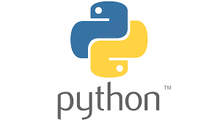

1. **Streamit:**

Streamlit is an open-source Python library that simplifies the creation of web applications for data science and machine learning projects. Launched in 2019, Streamlit has quickly gained popularity among data scientists and developers for its ability to turn data scripts into shareable web apps with minimal effort.

At its core, Streamlit allows users to create interactive, data-driven web applications using pure Python code. This approach eliminates the need for front-end development skills typically required for web application development, such as HTML, CSS, or JavaScript. Instead, developers can focus on their data analysis and visualization code, while Streamlit handles the web interface generation.

Streamlit's architecture is designed for simplicity and rapid development. When a Streamlit script is run, it generates a web application where each variable or function creates a user interface element. The library provides a wide range of UI components, including text inputs, buttons, sliders, and file uploaders, which can be easily integrated into the app with just a few lines of code.

One of Streamlit's key features is its ability to automatically rerun the entire script when any input widget is changed. This reactive execution model ensures that the app's state is always consistent with user inputs, simplifying the development of interactive applications. Streamlit also supports caching to optimize performance for computationally intensive operations.

For data visualization, Streamlit seamlessly idantegrates with popular Python libraries such as Matplotlib, Plotly, and Altair. This allows developers to create complex, interactive charts and graphs within their Streamlit apps. The library also supports the display of multimedia content, including images, videos, and audio files.

Streamlit's ecosystem includes Streamlit Components, which allows developers to create custom widgets and extend the library's functionality. This feature enables the integration of more advanced UI elements or third-party visualizations into Streamlit apps.

Deployment of Streamlit apps is straightforward, with options for cloud deployment through services like Streamlit Cloud (formerly Streamlit Sharing) or self-hosting on platforms like Heroku or AWS. This ease of deployment facilitates sharing and collaboration, making it simple for data scientists to showcase their work to stakeholders or the wider community.

In the data science workflow, Streamlit serves as a powerful tool for creating prototypes, dashboards, and interactive reports. It's particularly useful for quickly iterating on machine learning models, allowing data scientists to easily create interfaces for model demonstration and evaluation.

Recent updates to Streamlit have introduced features like multipage apps, allowing for more complex application structures, and improvements in app performance and customization options. The library continues to evolve, with an active community contributing to its development and expanding its capabilities.

Streamlit's simplicity, coupled with its powerful features, has made it a popular choice in various industries, from finance and healthcare to education and research. It's particularly valued in scenarios where rapid prototyping and deployment of data-driven applications are crucial.



1. **Pandas**

Pandas is a powerful, open-source data manipulation and analysis library for Python. Created by Wes McKinney in 2008 and released publicly in 2009, pandas has become an essential tool in the data science ecosystem, bridging the gap between the scientific computing capabilities of NumPy and the flexible data manipulation requirements of data analysis.

At its core, pandas provides two primary data structures: Series (one-dimensional) and DataFrame (two-dimensional). The DataFrame, in particular, has become ubiquitous in data analysis, offering a tabular, spreadsheet-like data structure with labeled axes (rows and columns). This structure allows for intuitive handling of heterogeneous data, much like a SQL table or an Excel spreadsheet, but with the added power of Python programming.

Pandas excels in handling various data formats. It can read and write data from multiple sources, including CSV, Excel, JSON, SQL databases, and more. This flexibility makes it invaluable for data ingestion and preparation tasks, often the most time-consuming parts of data analysis projects.

The library offers a rich set of functions for data manipulation. Operations like filtering, sorting, grouping, merging, and reshaping data are streamlined and efficient. Pandas' indexing capabilities are particularly powerful, allowing for complex data selection and transformation operations. The loc and iloc indexers provide intuitive ways to access data by label or position, respectively.

Time series functionality is another strength of pandas. It provides date range generation, frequency conversion, moving window statistics, and date shifting and lagging. These features make pandas particularly useful for financial analysis, scientific research, and any field dealing with time-indexed data.

Pandas integrates seamlessly with other libraries in the Python data science stack. It works well with NumPy for numerical computing, Matplotlib and Seaborn for visualization, and scikit-learn for machine learning. This interoperability allows for end-to-end data science workflows within the Python ecosystem.

The library's handling of missing data is sophisticated, offering various strategies for dealing with NaN (Not a Number) values. Methods for filling, dropping, or interpolating missing data provide flexibility in addressing this common challenge in real-world datasets.

Performance is a key focus of pandas. Many of its underlying operations are implemented in Cython or C, making it efficient for large datasets. Recent versions have introduced nullable integer data types and improved memory usage, further enhancing its capabilities for handling large-scale data.

Pandas also provides powerful tools for data aggregation and analysis. The groupby functionality allows for split-apply-combine operations, essential for summarizing and analyzing data across categories. Pivot tables and cross-tabulations are also supported, enabling complex data reshaping and summarization.

One of pandas' strengths is its ability to handle messy, real-world data. Functions for data cleaning, such as removing duplicates, replacing values, and renaming columns, make it easier to prepare data for analysis. The melt and pivot functions allow for easy conversion between wide and long data formats, accommodating different analytical needs.

Recent developments in pandas include improved support for categorical data, enhanced string handling capabilities, and better integration with Arrow for memory-efficient operations. The library continues to evolve, with ongoing efforts to improve performance and expand its functionality.

Pandas has found applications across various industries, from finance and economics to healthcare and social sciences. Its versatility makes it suitable for tasks ranging from simple data cleaning to complex statistical analysis and machine learning model preparation.



1. **Numpy**

NumPy (Numerical Python) is a fundamental package for scientific computing in Python. Created by Travis Oliphant in 2005, it evolved from earlier packages like Numeric and Numarray. NumPy has become the foundation of the Python scientific computing stack, providing powerful tools for handling large, multi-dimensional arrays and matrices, along with a vast collection of high-level mathematical functions.

At the core of NumPy is the ndarray (n-dimensional array) object, a fast, flexible container for large datasets in Python. Unlike Python's built-in lists, NumPy arrays are homogeneous (all elements must be of the same type) and offer significant performance improvements for numerical operations. This efficiency stems from NumPy's use of contiguous memory blocks and its ability to leverage optimized C code for many operations.

NumPy's array operations are vectorized, meaning they can be applied to entire arrays without explicit loops. This vectorization not only makes code more concise and readable but also significantly boosts performance, especially for large datasets. Operations that might take hundreds of lines in pure Python can often be expressed in a few lines with NumPy, running orders of magnitude faster.

The library provides a comprehensive set of mathematical functions for array operations. These include basic arithmetic operations, trigonometric functions, exponential and logarithmic functions, and statistical operations. NumPy also offers tools for linear algebra, including matrix operations, eigenvalue problems, and solving systems of linear equations.

One of NumPy's strengths is its broadcasting capability. This feature allows operations on arrays of different shapes, automatically replicating smaller arrays across larger ones. Broadcasting simplifies code and improves memory efficiency by avoiding unnecessary copies of data.

NumPy's random number generation capabilities are extensive, supporting various probability distributions. This functionality is crucial for simulations, statistical analyses, and machine learning applications where random sampling is required.

The library also provides tools for reading and writing array data to disk, supporting various file formats. This I/O capability, combined with NumPy's efficient memory usage, allows for handling datasets too large to fit in memory through memory-mapped file arrays.

NumPy's indexing and slicing operations are powerful and flexible. They allow for complex data selection and manipulation, including boolean indexing, which enables sophisticated filtering of data based on conditions.

In the realm of scientific computing, NumPy integrates seamlessly with other libraries. It forms the basis for pandas' DataFrame, is used extensively in SciPy for more advanced scientific computations, and serves as a fundamental data structure in machine learning libraries like scikit-learn and TensorFlow.

Recent developments in NumPy have focused on improving performance and expanding functionality. The introduction of generalized universal functions (gufuncs) allows for more flexible vectorized operations. Efforts are also underway to improve NumPy's ability to leverage modern hardware, including better support for GPU acceleration.

NumPy's applications span a wide range of fields, including physics, chemistry, astronomy, geosciences, bioinformatics, and many engineering disciplines. In data science and machine learning, it's often used for data preprocessing, feature engineering, and implementing algorithms from scratch.

The library's documentation is comprehensive, with a wealth of examples and tutorials, making it accessible to both beginners and advanced users. Its large and active community contributes to continuous improvements and provides support through various channels.

NumPy's influence extends beyond Python, serving as a model for array programming libraries in other languages. Its array protocol has been adopted by other Python libraries, ensuring interoperability across the scientific Python ecosystem.

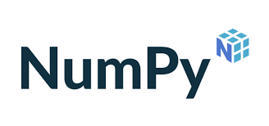

1. **Matplotlib:**

Matplotlib is a plotting library for Python and its numerical mathematics extension NumPy. Created by John D. Hunter in 2003, Matplotlib has become the foundational library for data visualization in the Python ecosystem. It provides a MATLAB-like interface for creating a wide variety of static, animated, and interactive visualizations.

At its core, Matplotlib offers two primary interfaces: a MATLAB-style state-based interface (pyplot) and an object-oriented interface. The pyplot interface is designed for simple plotting tasks and closely mimics MATLAB's plotting commands, making it easy for users familiar with MATLAB to transition to Python. The object-oriented interface, on the other hand, provides more fine-grained control over plot elements and is better suited for complex visualizations or when embedding plots in graphical user interfaces.

Matplotlib's architecture is highly modular, consisting of three main layers: the backend layer (for rendering plots), the artist layer (for representing graphical elements), and the scripting layer (for user interaction). This design allows for flexibility in output formats, including PNG, PDF, SVG, and interactive displays.

The library supports a vast array of plot types, including line plots, scatter plots, bar charts, histograms, pie charts, stem plots, contour plots, 3D plots, and many more. It also provides tools for creating more specialized visualizations like error bars, filled areas, and streamplots. This versatility makes Matplotlib suitable for a wide range of scientific and statistical visualizations.

One of Matplotlib's strengths is its customization capabilities. Users have fine-grained control over virtually every aspect of a plot, from colors and line styles to fonts and axis properties. This level of customization allows for the creation of publication-quality figures tailored to specific requirements.

Matplotlib integrates seamlessly with NumPy and can work directly with NumPy arrays. This integration extends to other libraries in the scientific Python ecosystem, such as pandas and SciPy, allowing for easy visualization of data from these sources.

The library also supports LaTeX rendering for mathematical expressions, enabling the inclusion of complex equations and symbols in plot labels and annotations. This feature is particularly valuable in scientific and engineering applications.

Animation support is another key feature of Matplotlib. It provides tools for creating both simple animations and complex, interactive visualizations. This capability is useful for visualizing time-series data, demonstrating algorithmic processes, or creating educational materials.

Matplotlib's event handling system allows for the creation of interactive plots. Users can implement features like zooming, panning, and click events, making it possible to build dynamic, responsive visualizations.

The library is designed with extensibility in mind. It supports custom projections, transformations, and backend systems, allowing advanced users to extend its capabilities for specialized needs.

Recent developments in Matplotlib have focused on improving performance, enhancing 3D plotting capabilities, and providing better support for large datasets. The introduction of style sheets has made it easier to create consistently styled visualizations across projects.

Matplotlib's influence extends beyond direct usage. It serves as the foundation for higher-level plotting libraries like Seaborn, which provides a more user-friendly interface for statistical graphics, and has inspired the design of other visualization libraries in the Python ecosystem.

The library's comprehensive documentation, including a gallery of examples, tutorials, and detailed API references, makes it accessible to users of all levels. Its large and active community contributes to continuous improvements and provides support through various channels.

Matplotlib finds applications across various domains, including scientific research, data analysis, machine learning, financial modeling, and more. Its ability to create a wide range of plot types makes it a versatile tool for visualizing data in fields ranging from physics and astronomy to social sciences and business analytics.

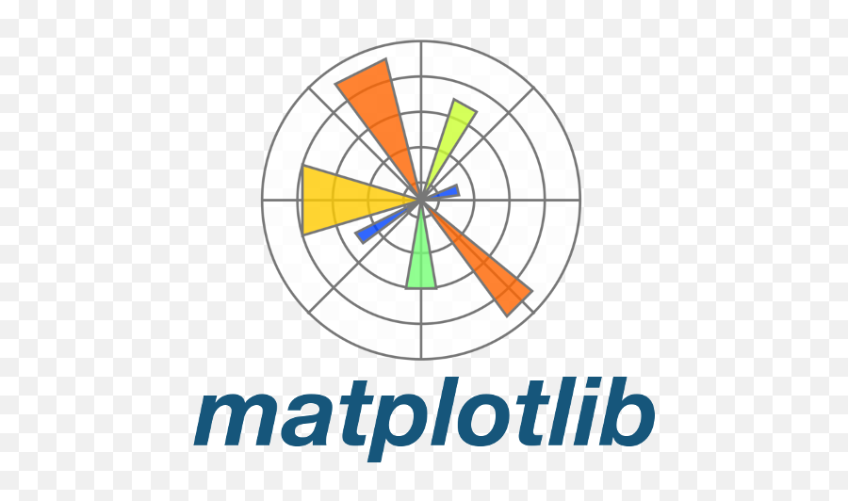

1. **Seaborn :**

Seaborn is a statistical data visualization library built on top of Matplotlib and closely integrated with pandas data structures in Python. Created by Michael Waskom in 2012, Seaborn has become a popular choice for creating attractive and informative statistical graphics with minimal code.

At its core, Seaborn aims to make visualization a central part of exploring and understanding data. It provides a high-level interface for drawing attractive and informative statistical graphics, abstracting many of the low-level details that Matplotlib requires. This approach allows users to create complex visualizations with just a few lines of code, making it particularly appealing for data scientists and statisticians.

Seaborn is designed to work seamlessly with pandas DataFrames, leveraging the powerful data manipulation capabilities of pandas to simplify the process of visualization. It can automatically recognize the data types in a DataFrame and choose appropriate plot types and statistical transformations.



**Key Insights and Findings**

Summarized the key insights and findings from the analysis, inclu ding:

* Major trends in crime rates over the years
* The most prevalent types of crimes
* Geographical hotspots for different crime categories
* Efficiency of police and judicial systems in handling crimes
* Demographics of individuals involved in crimes

**CHAPTER 7**

**DESIGN & IMPLEMENTATION**

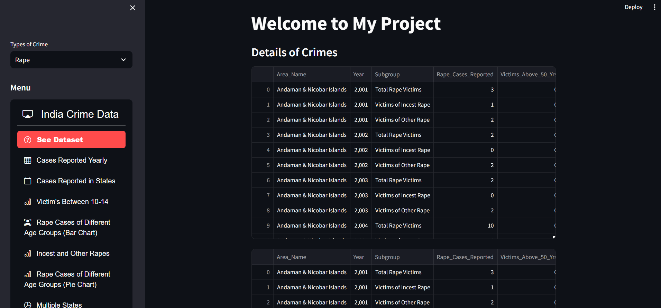

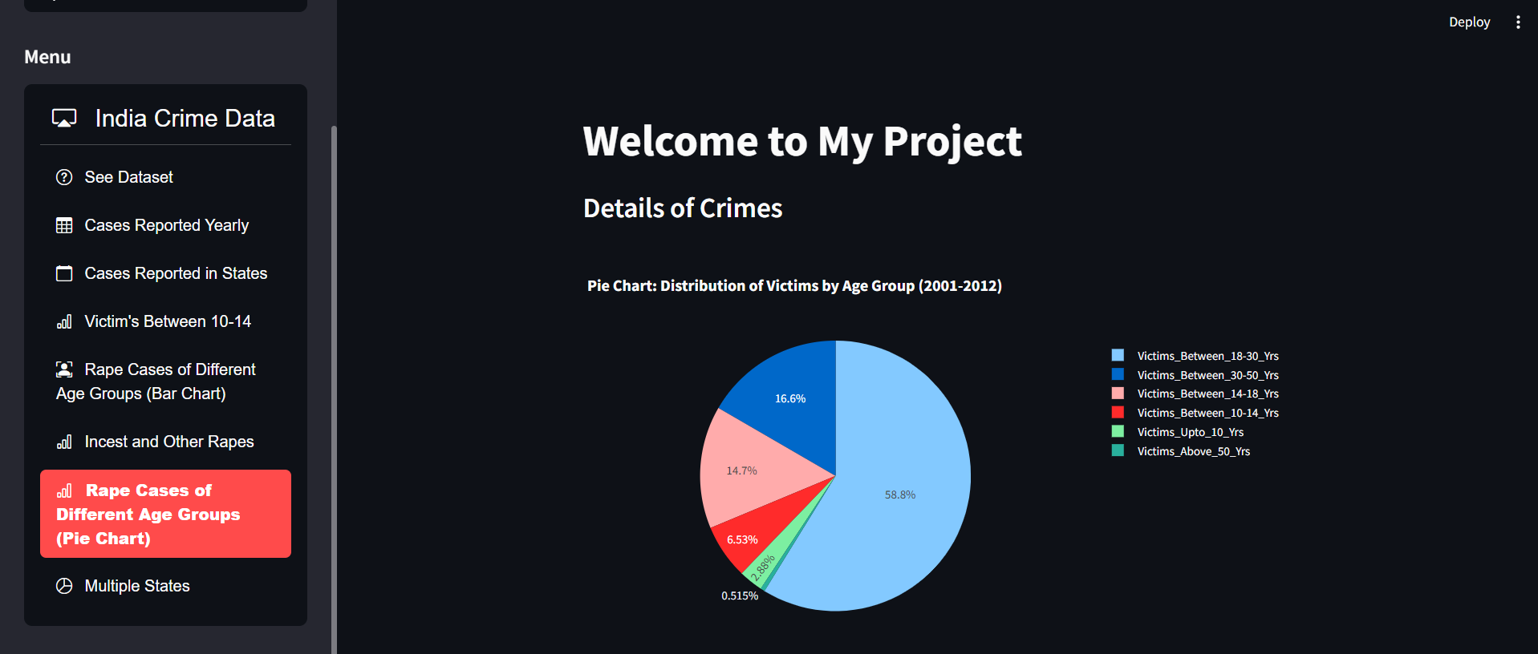

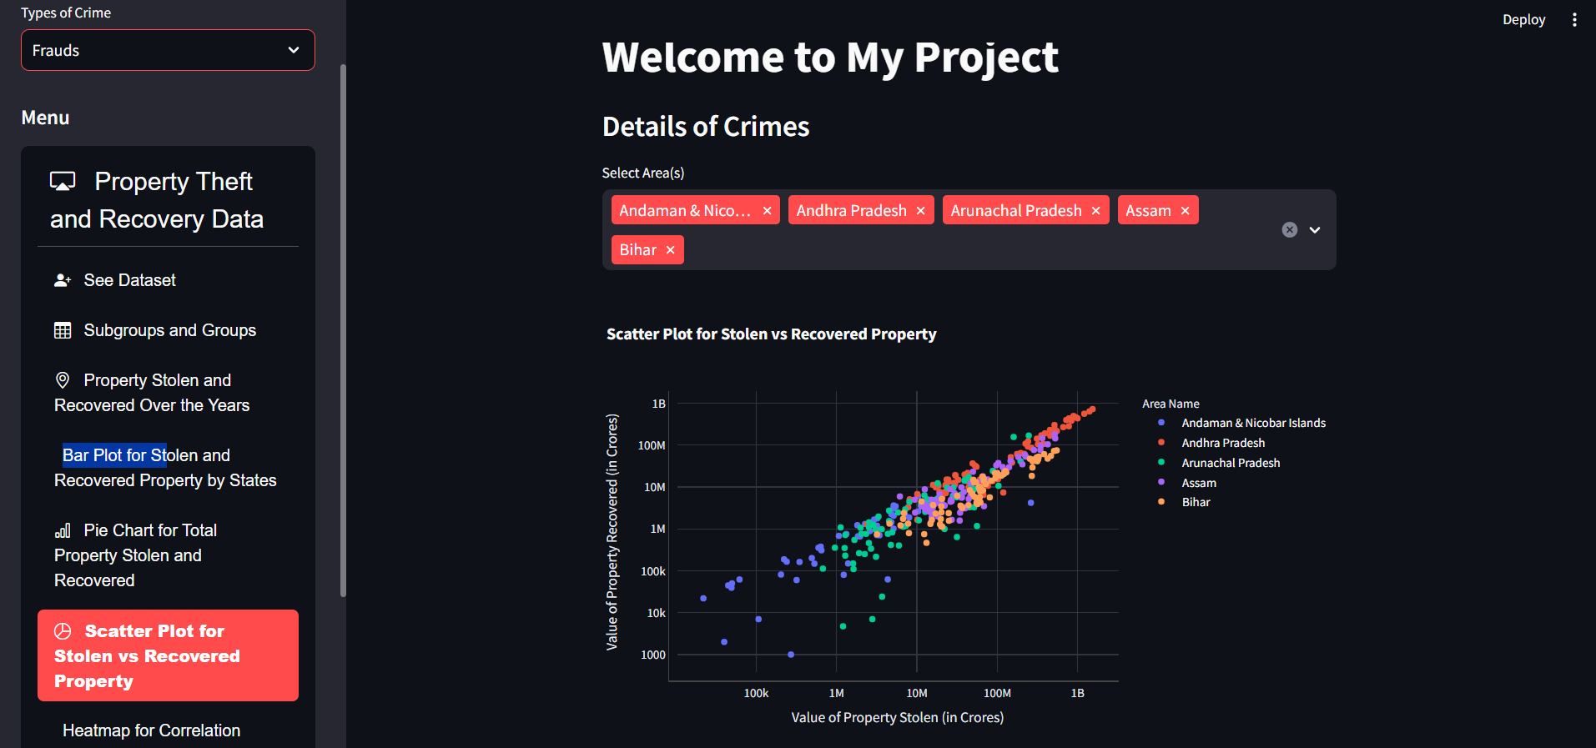

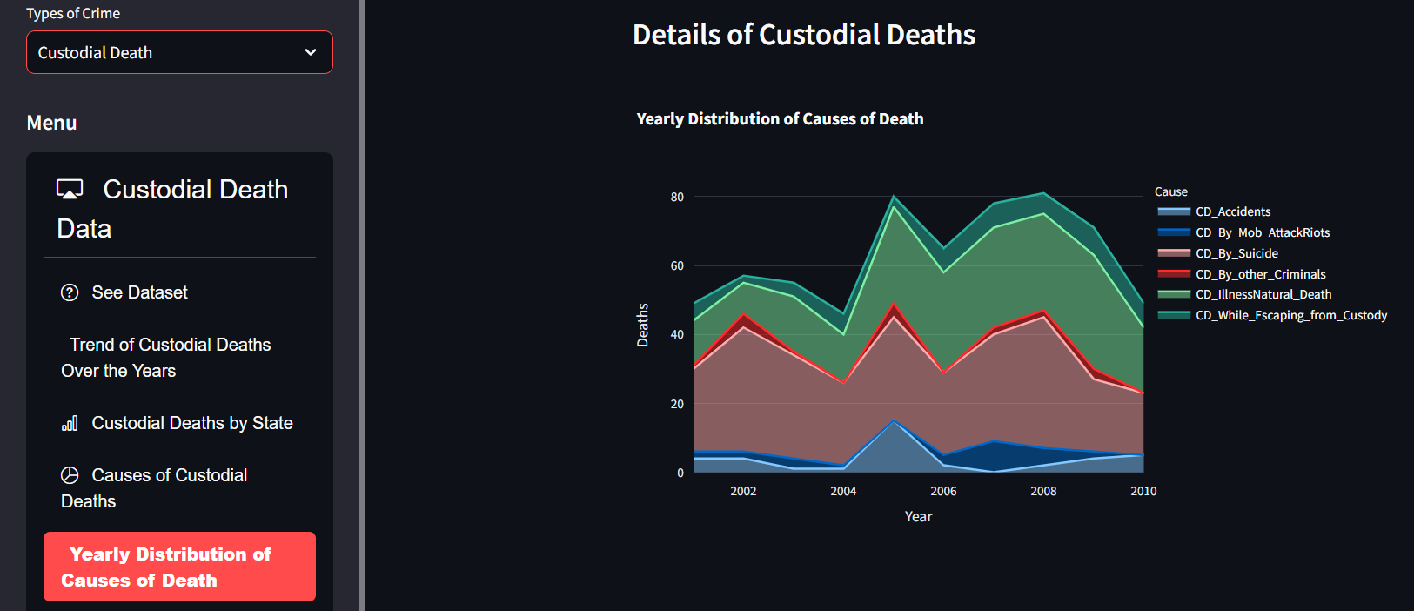

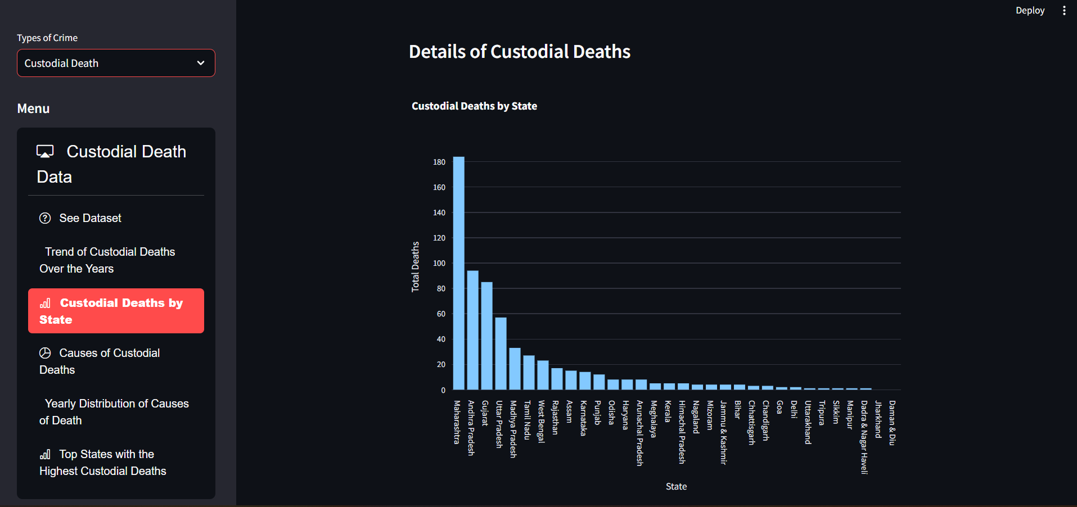

### **CHAPTER 8**

**CONCLUSION & FUTURE SCOPE**

### **Conclusion**

### The Crime Analysis Report project leverages data science techniques to analyze crime patterns and trends, providing valuable insights for law enforcement agencies and policymakers. By utilizing various data sources, the project identifies crime hotspots, temporal patterns, and correlations between different types of crimes. This information can help authorities allocate resources more effectively, design targeted crime prevention strategies, and improve overall public safety. The project demonstrates the potential of data-driven approaches in addressing complex societal issues like crime.

### **Future Scope:**

### **Integration of Real-Time Data:**

### Incorporating real-time crime data feeds could enhance the project's utility by enabling live monitoring and immediate response capabilities.

### **Advanced Predictive Analytics:**

### Developing predictive models to forecast future crime trends based on historical data, social factors, and economic indicators can help in proactive policing.

### **Geospatial Analysis:**

### Further refinement of geospatial analysis techniques, including the use of Geographic Information Systems (GIS), can provide more granular insights into crime distribution and assist in urban planning and law enforcement.

### **Machine Learning and AI:**

### Applying advanced machine learning algorithms and AI to identify hidden patterns and anomalies in crime data could improve the accuracy of predictions and uncover new insights.

### **Community Engagement Platforms:**

### Developing platforms that allow communities to report crimes and share information anonymously can help in gathering more comprehensive data and fostering collaboration between the public and law enforcement.

### **Cross-Referencing with Other Datasets:**

### Integrating crime data with other datasets, such as demographic, economic, and social data, can provide a more holistic view of the factors influencing crime and lead to more effective interventions.

### **Policy Recommendation Tools:**

### Creating tools that can simulate the impact of different policy decisions on crime rates could assist policymakers in crafting more effective crime prevention strategies.

### This project has the potential to evolve into a comprehensive crime analysis platform that can significantly contribute to improving public safety and reducing crime rates in the long term.

### **References**

* National Crime Records Bureau (NCRB), India
* Ministry of Home Affairs, India
* Various state and district police departments